Practical No. 1

Name: Mithrajeeth Yadavar

Roll no.: 223A1138

Class: TE-CE D

Aim: Write detailed problem statement and design dimensional modelling. (Star & Snowflake Schema)

**STREAMING PLATFORM:**

Information Package Diagram:

| **Dimension Table** | | | |
| --- | --- | --- | --- |
| **Users** | **Content** | **Genres** | **Time** |
| UserName (PK) | Content Name (PK) | Genre Type (PK) | Membership Duration (PK) |
| Payment details | Publisher Name | Group of contents | Date of Renewal |
| Wish List | Content type | Liked Genres | Date of Expiry |
| Content Preferences | Content Rating |  |  |
| **Fact Table** | | | |
| Analyse viewing patterns | | Content Popularity | |

**Star Schema Diagram:**   
  
  
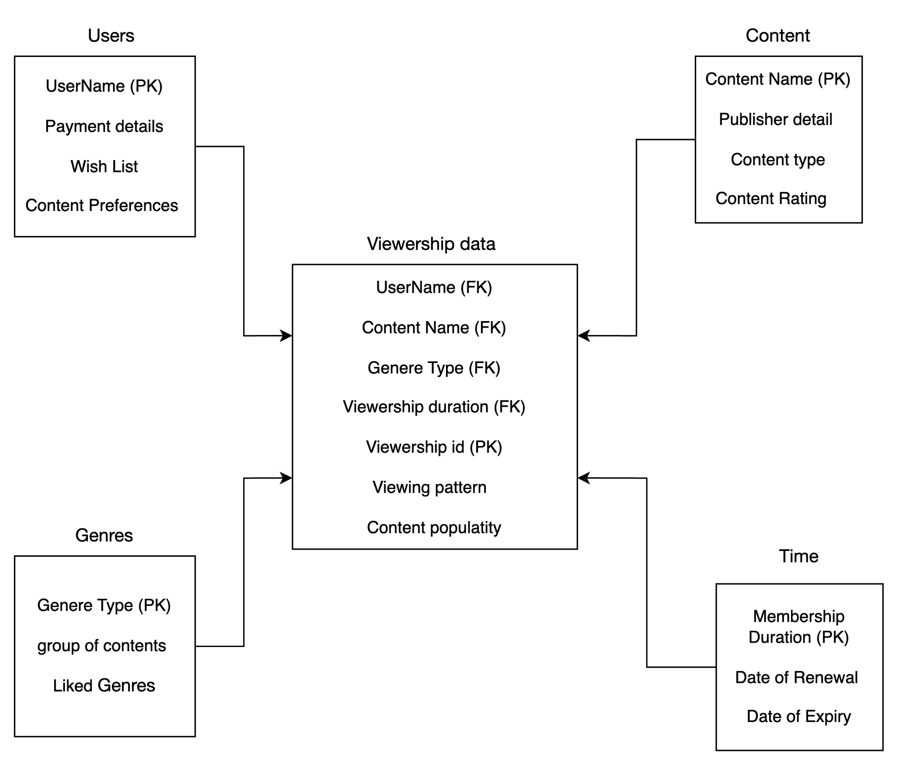

**Snowflake Schema Diagram:**

